COSC 4333: Distributed Systems
Assignment 2
Due: 10:00am, Sept. 20, 2024 (Friday)

Name: ____Andrew Kalathra___

LUID: _____L20498001________

Date: _______09/20/24_______

(20 points) In the Chord system, how does a node join the system? How does a node leave the system?
- To join:
  - A node is given an m-bit random identifier.
  - Then, the node must have a finger table to store any incoming entities that must be stored there.
  - Using consistent hashing, “certain keys previously assigned to [it’s] successor now become assigned to [it]”.
  - The node must also update its successor and predecessor as well as the successor’s predecessor to itself, as well as the predecessor’s successor to itself.
  - Everything else stays the same.
- To leave:
  - Assuming the node has keys in its node (not empty), then the keys must be distributed.
  - The node that is leaving must identify the predecessor and successor nodes.
  - The node n (the one that is leaving) must set the predecessor to n’s successor as n’s predecessor, as well as set the successor to n’s predecessor to n’s successor.
  - Finally, the key’s that n contains must be distributed.
- https://pdos.csail.mit.edu/papers/ton:chord/paper-ton.pdf

(20 points) What is the basic architecture of a NFS system for UNIX?
- NFS means Network File System. This is a protocol that is used in mounting to mount a remote file system onto a local file system.
- In UNIX, this is commonly used for foreign name spaces in distributed systems. The local machine has a root folder that then trickles down across various directories. Amongst these, there is a mounting point. This mounting point contains a URL that consists of three parts:
  - The name of the access protocol (which in this case would be NFS)
  - The name of the server (the remote machine)
  - And the name of the mounting point in the foreign name space.
- The remote name server has a foreign name space also has its own tree file system. Amongst these is the location of what is considered the “mounting point”, or where the name space will begin on the local machine.

(60 points) This question is about socket programming.
- Download “example socket program” (socket_program.tar.gz) under the folder “Socket Programming”

- Upload socket_program.tar.gz to a Linux machine, then run:
  - gunzip socket_program.tar.gz
  - tar xvf socket_program.tar

you will then obtain a list of socket programs. Please refer to video “Socket Programming Video” to see how to use these socket programs.
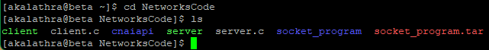

- In these socket programs, there are client.c and server.c. Please compile and run these two programs and make them work. Please:
  - Explain the basic functionality of server.c and client.c
  - In server.c
    - The main method contains a few variables. The main ones include a variable to hold the server socket address, denoted as sad, and a variable to hold the client socket address, denoted as cad. Another important variable is the port variable, which holds the port number. Finally, the last important variable is the visits variable, which is a counter that stores the amount of visits received.
    - All other variables are there but not important to this discussion.
    - The first if-else statement checks if a port was specified. If it was, then the port variable is set to the input, otherwise the port is automatically set to the default port.
    - The second if-else statement just checks for illegal ports.
    - The third if-else statement is irrelevant. (use TCP protocol)
    - Two variable are then defined, sd and sd2, as a socket functions. These functions have 3 parameters and are used to make a socket. The following if statement is used to check it for errors, with the next if statement used to bind a local address to the socket.
    - Following this, the server listens for a connection.
    - When the server gets a request, the while loop will start.
      - A new socket will be created, sd2, to transfer a line. The if statement will show an error if the socket cannot be made, or
      - The number of visits will increment by 1. Then the line “This server has been contacted # times” will be printed with the # representing the variable visits.
    - The socket will then close at the end of this while loop. This is an infinite loop, so it will continue to listen until the server stops running.
  - In client.c
    - The main method contains a few similar variables. There is a variable to hold the IP address of the server, denoted as sad. Alongside this, there is still the port number that has the same function, to connect to the right port.
    - The same two if-else statements are used to connect to the specified port, or if none is given, then to the default port.
    - Additionally, an if-else statement is given to check the host. If none is given, then the default host will be assigned. (This is the server host). A few more if-else statements are meant to run through connecting/mapping the host and protocol number.
    - A socket is then created, sd, with its own if statement checker and connection checker.
    - The client then receives from sd, stores the buffer in a variable n, prints the buffer, prints the length of n, and then clears n (and prints that length as well).
    - Following this, the client closes the socket using the closesocket api.
  - Run server and client.
  - Turn in a screenshot to show how you run them.
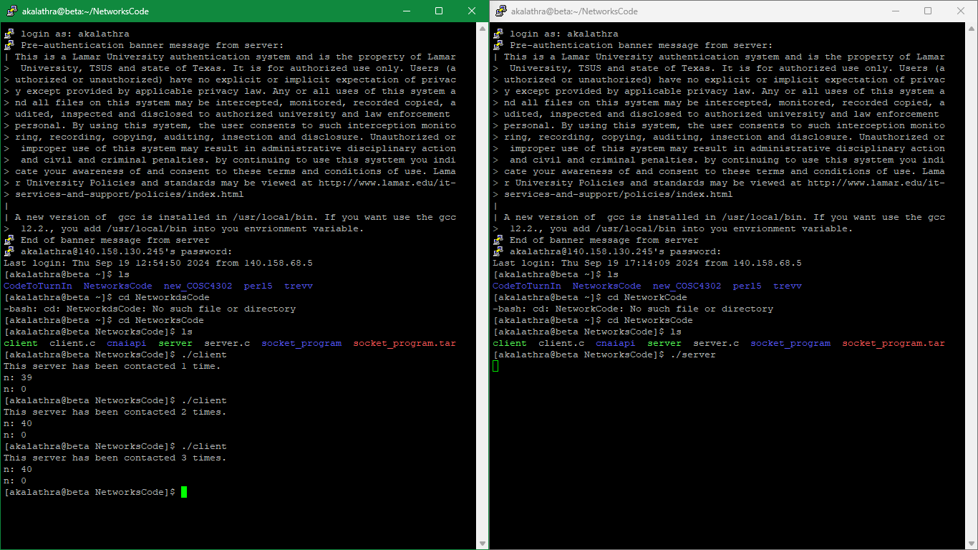

- In these socket programs, there are webclient.c and webserver.c. These two programs implement a simple web client and web server. Please:
  - Explain the basic functionality of webserver.c and webclient.c
    - The webserver.c program starts off with a few defined errors and a home page (all HTML). Two functions are also listed, “recvln” and “send_head”. The main method starts by listing variables. There is a system check (linux or windows). The server then waits for contact. When contacted, different commands can be entered alongside different paths, all which needs to be parsed utilizing the “recvln” function. Later on, there is a checker for if the path included “/time”, in which there is an if statement that is designated to return the time of the day (with specifications for each system).
    - The webclient.c main method starts with a list of variable names. After a few error checks, a connection method (using two parameters) is used to contact the server. The input given is first converted into what the computer can understand, such as numbers. There is a specified Get command that is sent to the server. Any information received from the server will be captured as the parameter buff in the method “recv” and then printed out to the terminal.
  - Run webserver and webclient.
  - Turn in a screenshot to show how you run them.
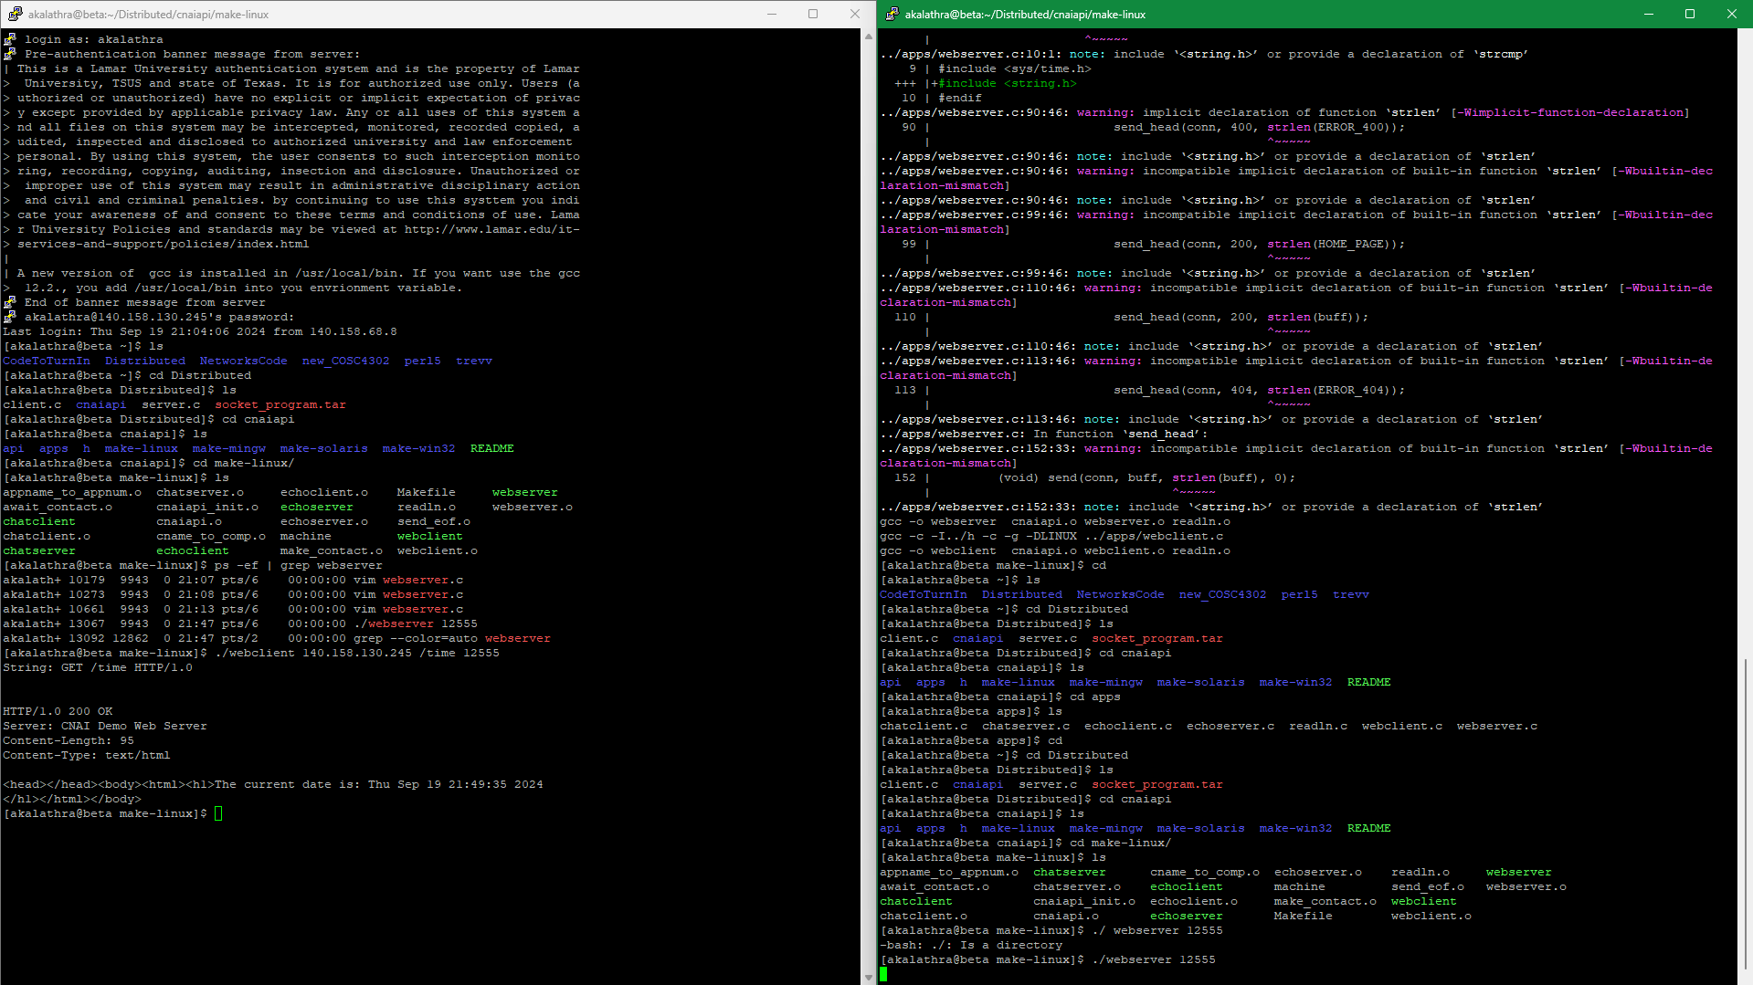
- I followed the video step by step, hence the same port (and same mistakes when finding the webserver.c).

How to Turn In:
Softcopy: Please use BlackBoard to turn in your homework solutions.

